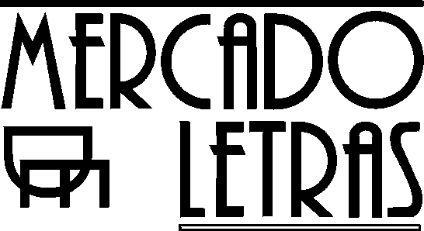

O U S O R I T U A L D A A Y A H U A S C A

[THE RITUAL USE OF AYAHUASCA]

Editors: Beatriz Caiuby Labate, PhD candidate in Social Science at UNICAMP (Awarded best master thesis in Social Science by ANPOCS, 2000) and Wladimyr Sena Araújo, PhD candidate in Social History at UNICAMP.

Publisher: Editora Mercado de Letras, Campinas/SP - Brazil
Tel: 55 + 19 + 3241 7514
Format: 16 X 23 cm, illustrated
Support from the Fapesp (Research Support Foundation of the State of São Paulo)
736 pp.
Second edition, revised and updated: 2004 (1st. Ed.: 2002)
Price: R$ 75,00 (US$ 28,00 + shipping fee)

Summary:

This collection consists of 26 articles written by authors from 7 different countries. It represents the most important effort at reflection undertaken in Brazil until today on the consumption of ayahuasca, the “vine of the dead”, an age-old sacred drink made from two Amazonian plants: the vine Banisteriopsis caapi and the shrub Psychotria viridis. The book offers a combined panel on the spectrum of the ritual uses of this psychoactive substance in South America. The first part deals with its uses by indigenous populations and rubber-workers in Amazonia. The central part of the work deals with the original and quite controversial Brazilian ayahuascan religions, popularly known as Santo Daime, União do Vegetal and Barquinha. These religions extrapolate the limits of their origin, having been exported to the major urban centers of the country and even abroad, currently including more than ten thousand followers. This rich and dynamic cultural phenomenon is contemplated in dialogue, also, with the debate over the utilization of psychoactive substances in our society. Finally, the last part of the work brings together the perspectives of medicine, psychology, and ethnopharmacology on these diverse ritual uses of the substance. The volume presents a focus that is both comparative and multidisciplinary, providing a panorama that is impressive for its wealth of information and perspectives, including both the opinions of diverse academic specialists and the point of view of ayahuasca users themselves. The work is of interest to Anthropology, History, Religion, Psychology, Philosophy, Law and the new area called Entheobotany, or the study of sacred plants (Translated by Robin Wright).

Contact in Brazil: livros@mercado-de-letras.com.br
Foreign contacts: Livraria Pontes – pontes@lexxa.com.br
http://www.mercado-de-letras.com.br

