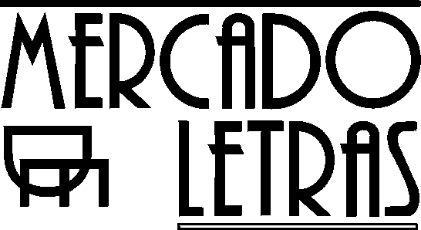
PRESS RELEASE

O U S O R I T U A L D A A Y A H U A S C A

Editors: Beatriz Caiuby Labate, UNICAMP and Wladimyr Sena Araújo, UNICAMP.

Publisher: Editora Mercado de Letras, Campinas/SP/Brazil
Tel: (55-19) 3241 7514
Format: 16 X 23 cm, illustrated
688 pp.
Price: R$ 49,00 (= US$ 10.30)

Summary:

This collection consists of 24 articles written by authors from 7 different countries. It represents the most important effort at reflection undertaken in Brazil until today on the consumption of ayahuasca, the “vine of the dead”, an age-old sacred drink made from two Amazonian plants: the vine Banisteriopsis caapi and the shrub Psychotria viridis. The book offers a combined panel on the spectrum of the ritual uses of this psychoactive substance in South America. The first part deals with its uses by indigenous populations and rubber-workers in Amazonia. The central part of the work deals with the original and quite controversial Brazilian ayahuascan religions, popularly known as Santo Daime, União do Vegetal and Barquinha. These religions extrapolate the limits of their origin, having been exported to the major urban centers of the country and even abroad, currently including more than ten thousand followers. This rich and dynamic cultural phenomenon is contemplated in dialogue, also, with the debate over the utilization of psychoactive substances in our society. Finally, the last part of the work brings together the perspectives of medicine, psychology, and ethnopharmacology on these diverse ritual uses of the substance. The volume presents a focus that is both comparative and multidisciplinary, providing a panorama that is impressive for its wealth of information and perspectives, including both the opinions of diverse academic specialists and the point of view of ayahuasca users themselves. The work is of interest to Anthropology, History, Religion, Psychology, Philosophy, Law and the new area called Entheobotany, or the study of sacred plants.

Contacts:

To buy books: livros@mercado-de-letras.com.br or http://www.mercado-de-letras.com.br

To negotiate author´s rights: Maria Eliza: m_letras@uol.com.br

